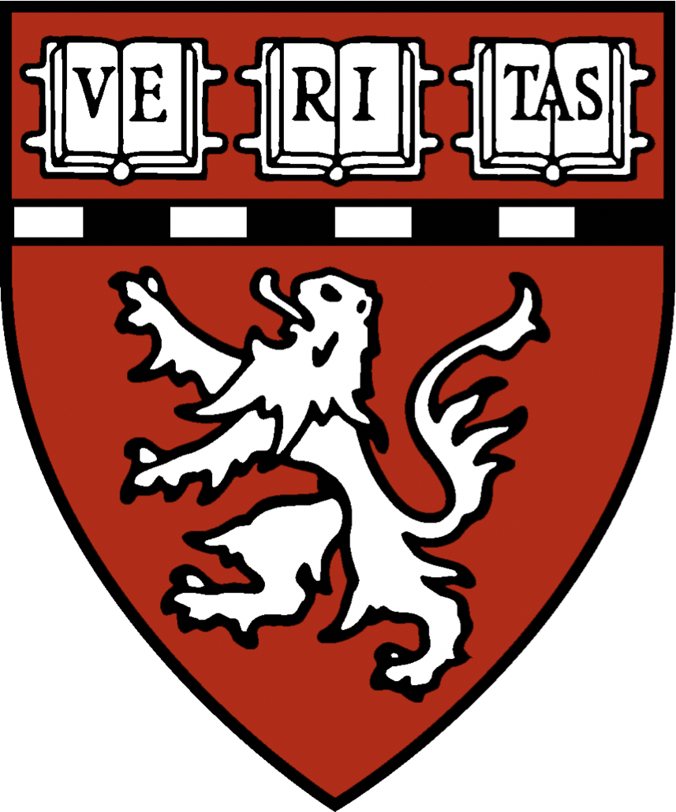
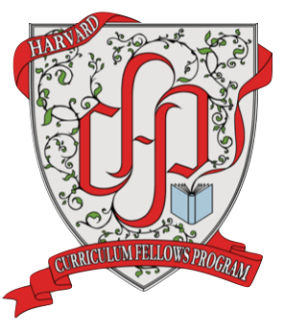
Curriculum Fellow in Cell Biology
Institution: Harvard Medical School
Location: Boston, MA
Category: Faculty - Science
Type: Full Time

Harvard Medical School’s Curriculum Fellows Program (CFP) is pleased to announce a full-time Curriculum Fellow position in the Department of Cell Biology. This is an exciting opportunity to work with faculty members within the Department of Cell Biology to develop, implement, and research novel training opportunities for Cell Biology graduate students.
The CFP is a postdoctoral service and training program focused on curriculum development, teaching, and educational programming in the biological and biomedical sciences. Curriculum Fellows work closely with members of the HMS faculty and administration to develop, deploy, and evaluate evidence-based graduate training. Fellows also receive mentorship and career advising to support their development as educators and help them succeed in a variety of education-focused careers. More detailed information about the Curriculum Fellows Program and the role of a CF can be found in the 2021 CF cohort announcement available on our website.
The primary responsibility of the Curriculum Fellow in Cell Biology will be to develop and support graduate-level curriculum in the Department of Cell Biology and to support a major NIGMS-funded T32 training grant: Molecular, Cellular, and Developmental Dynamics (MCD²).
Responsibilities include:
- Working with faculty course directors and the PI of the MCD² training grant to manage and innovate courses offered by the Department of Cell Biology.
- Participating in the administration and planning of Cell Biology 201, a course that is required for all first-year students in the Biological and Biomedical Sciences (BBS) graduate program.
- Organizing and overseeing multiple short courses, including nanocourses (two-day courses that teach transferrable skills and update the community on the latest techniques and discoveries) and a two-week course in experimental design, platforms, and analytics.
- Collecting and analyzing student academic and career outcomes data to formally evaluate the MCD² training program.
- Preparing components of annual progress reports for the T32 training grant, administrative supplement applications to drive program innovation, and the competing renewal application for the T32 program.
- Working with faculty and students to develop and manage para-curricular activities that serve MCD² training goals.

Qualifications, job skills, and competencies:
- Ph.D. in Cell Biology or a closely related area by the time of appointment.
- Prior experience or demonstrated interest in teaching.
- Outstanding writing and organizational skills.
- Demonstrated capacity for independence, perseverance, and innovation, as well as the ability to work as part of a team.

Fellowships are intended for early-career scientist-educators. The CF appointment is renewable annually for a maximum of three years and is non-tenure-track. Fellows are appointed as Research Fellows and typically earn promotion to the rank of Lecturer during the term of the fellowship. The ideal start date for the Curriculum Fellow in Cell Biology is shortly after August 1st, 2021. The current COVID-19 restrictions in place at Harvard Medical School mean this position is likely to begin remotely, but fellows will be expected to work in person in Boston, MA when this becomes possible.

To apply:
Applicants should provide an application package that includes a cover letter that describes your interest in and qualifications for this position, a CV, a teaching statement, and the names and contact information of three professional references. The teaching statement is an opportunity to describe your philosophy of teaching in the context of your own experiences. Submissions will be evaluated according to the guidelines found on our website. A discussion of diversity, equity and inclusion is an important component of the teaching statement.

Address emails to cfp@hms.harvard.edu, attention Dr. Bradley Coleman, Director of the HMS Curriculum Fellows Program. Review of applications will begin on May 17th and will continue until the position is filled.

We are an equal opportunity employer and all qualified applicants will receive consideration for employment without regard to race, color, religion, sex, national origin, disability status, protected veteran status, gender identity, sexual orientation, pregnancy and pregnancy-related conditions or any other characteristic protected by law.

